**IMPLEMENTING STANDARD AND ARCHIVE BUCKETS WITH VERSIONING AND LIFECYCLE POLICIES**

A Project Report Submitted in the fulfilment of the requirements for

Final-Project Evaluation



**SANJANA S**

**2320778**

**GenC Intern**

**CONTENTS**

**INTRODUCTION**

**OBJECTIVE**

**SOFTWARE REQUIRED**

**PROJECT REQUIREMENT**

**IMPLEMENTATION**

**CONCLUSION**

**INTRODUCTION**

In the ever-expanding landscape of cloud computing, efficient data storage management is paramount for organizations to balance performance, accessibility, and cost-effectiveness. Google Cloud Platform (GCP) offers a comprehensive suite of storage solutions tailored to meet diverse needs, including Standard and Archive buckets, each optimized for specific use cases. In this project, we explore the implementation of Standard and Archive buckets on GCP, coupled with essential features such as versioning and lifecycle policies. This strategic approach aims to optimize data storage utilization, enhance data durability, and streamline data lifecycle management, empowering organizations to make informed decisions regarding their data storage strategies. Through careful planning and execution, businesses can harness the full potential of GCP's storage offerings while minimizing operational overhead and maximizing cost efficiency.

**OBJECTIVES**

The objective of this project is to demonstrate the practical implementation of Standard and Archive buckets on Google Cloud Platform (GCP), augmented with versioning and lifecycle policies. By achieving this objective, we aim to:

* Optimize Data Storage: Design and deploy storage solutions tailored to specific data access patterns and lifecycle requirements, maximizing efficiency and minimizing costs.
* Ensure Data Durability: Implement versioning to safeguard against accidental deletions or modifications, ensuring the integrity and availability of critical data.
* Streamline Data Lifecycle Management: Utilize lifecycle policies to automate the transition of objects from standard to archive storage based on defined criteria, simplifying data management workflows and minimizing manual intervention.
* Enable Scalability and Flexibility: Leverage GCP's scalable infrastructure to accommodate evolving storage needs and adapt to changing business requirements seamlessly.
* Empower Decision-Making: Provide organizations with actionable insights into optimizing data storage strategies, enabling informed decision-making and resource allocation.

By accomplishing these objectives, this project aims to empower organizations to leverage GCP's storage capabilities effectively, driving operational efficiency, and enhancing data governance practices.

**SOFTWARE REQUIRED**

The software required for this project includes:

Google Cloud Platform (GCP) Account: Sign up for a GCP account if you don't have one already. This provides access to GCP's storage services, including Cloud Storage for creating buckets and managing data.

Google Cloud Console: Access the Google Cloud Console, a web-based interface provided by GCP, for performing tasks such as creating buckets, configuring lifecycle policies, and monitoring storage usage. This can be used alongside the command-line tools for convenience. It includes the gcloud command-line tool and gsutil utility for interacting with GCP services from the command line. This is essential for creating and managing buckets, implementing lifecycle policies, and configuring versioning.

Text Editor or IDE: You may need a text editor or an Integrated Development Environment (IDE) for writing scripts, configurations, or documentation related to the project. Popular options include Visual Studio Code, Sublime Text, or Atom.

Google Cloud Storage Client Libraries: Depending on the project's requirements, you may choose to use client libraries provided by Google Cloud Storage for interacting with GCP programmatically using languages such as Python, Java, or Node.js.

By leveraging these software tools and platforms, the project tasks related to creating Standard and Archive buckets, implementing versioning, and configuring lifecycle policies on Google Cloud Platform has been executed.

**PROJECT REQUIREMENTS**

The project aims to establish a robust data management system on Google Cloud Platform (GCP) by leveraging Cloud Storage capabilities to create standard and archive buckets with versioning and lifecycle policies. This comprehensive solution ensures efficient storage, management, and transition of data between storage tiers, optimizing cost and accessibility within the GCP ecosystem.

It includes:

**1. Creation of Standard and Archive Buckets:** The project begins with the creation of standard and archive buckets within Google Cloud Storage. These buckets provide distinct storage tiers optimized for different data access patterns and retention requirements.

**2. Versioning Implementation:** Versioning is enabled for both standard and archive buckets, ensuring that multiple versions of objects can be stored and accessed. This feature enhances data integrity and provides a historical record of changes made to stored objects over time.

**3. Lifecycle Management Policies**: Lifecycle management policies are defined and applied to the buckets, allowing automated management of objects based on predefined rules. This includes actions such as transitioning objects to different storage classes, deletion of outdated data, and archiving of inactive data.

**4. Data Movement from Standard to Archive Bucket:** Data movement policies are established to automatically transition objects from the standard bucket to the archive bucket based on specified criteria such as age, access frequency, or custom metadata. This ensures that infrequently accessed or cold data is stored in the more cost-effective archive storage tier while remaining accessible when needed.

**IMPLEMENTATION**

Via GUI Method

Create a standard bucket

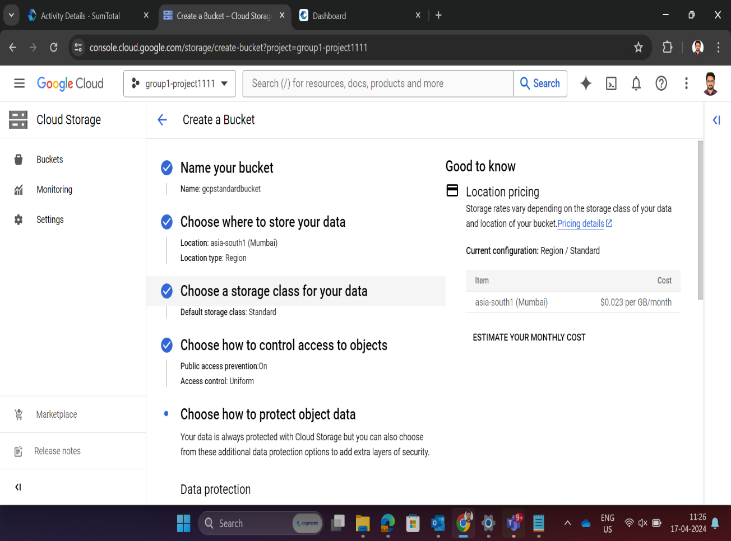

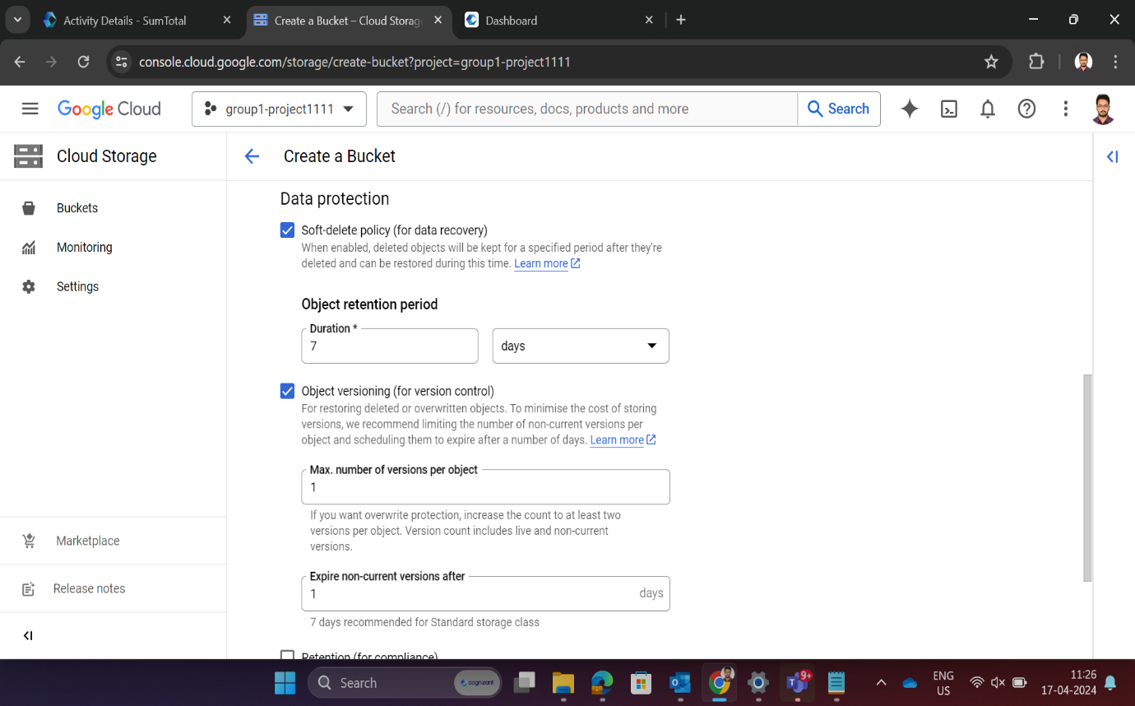 Enable Versioning

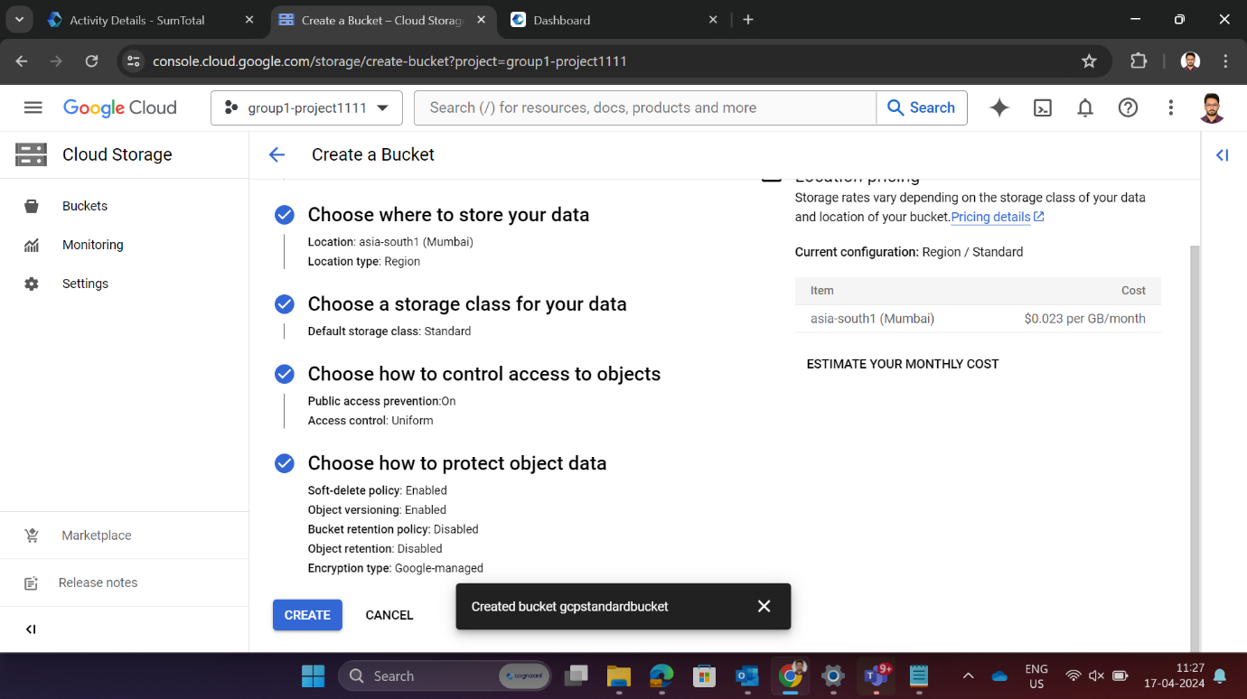Standard bucket

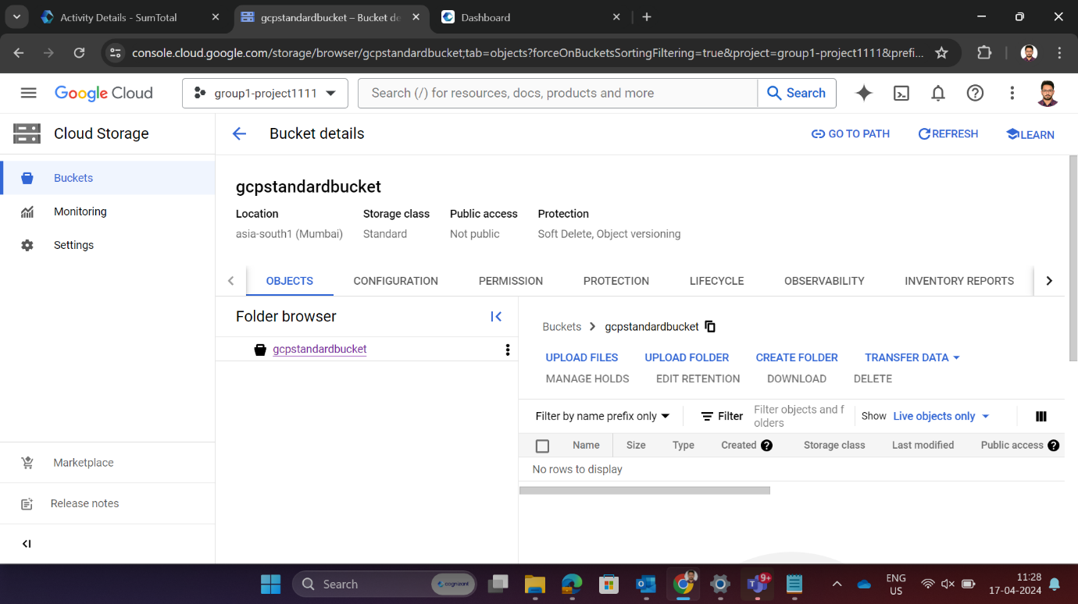

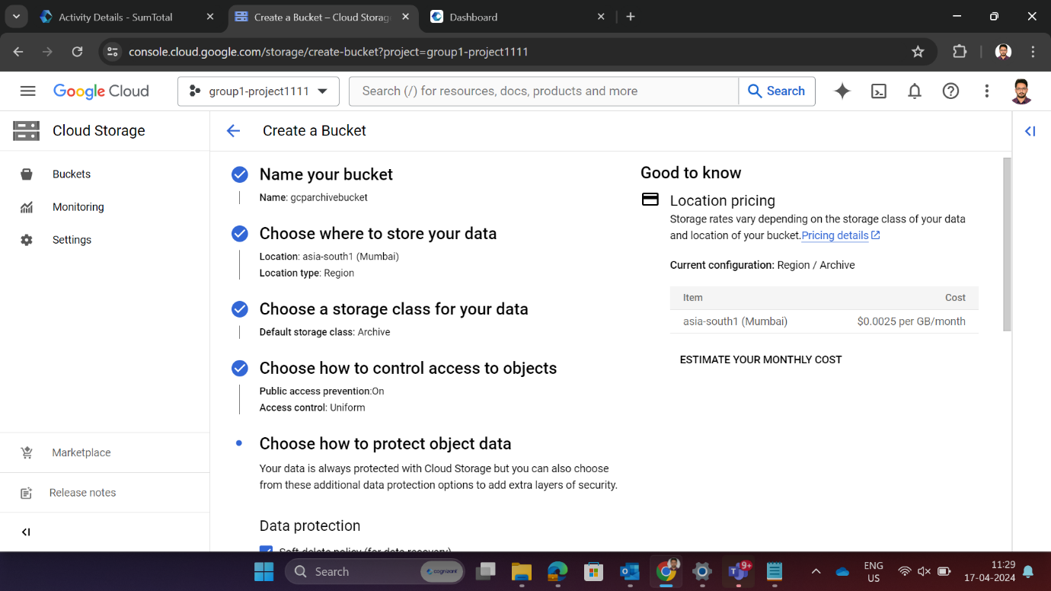Create a archive bucket

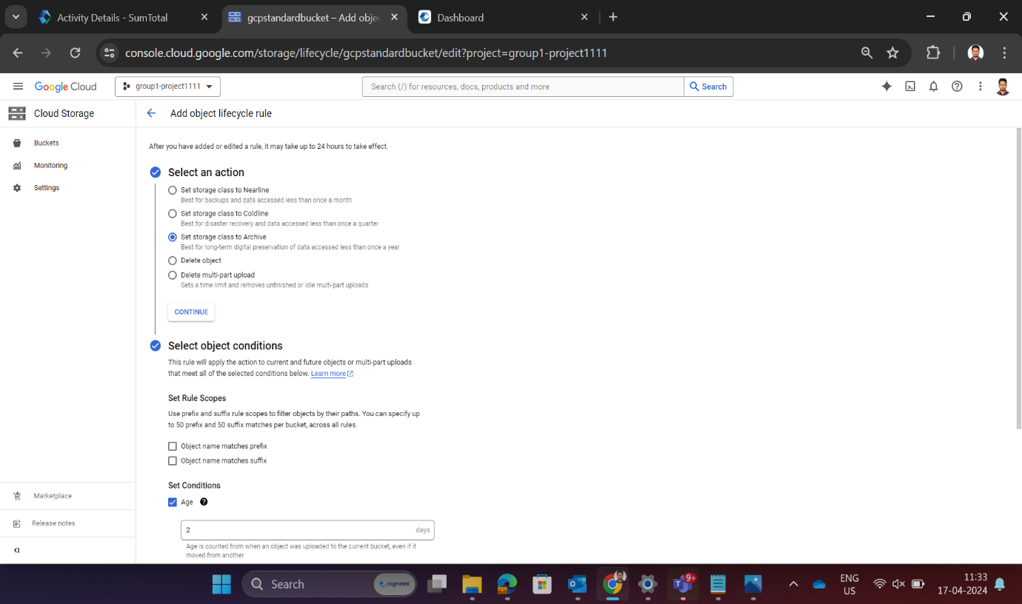Enable Versioning

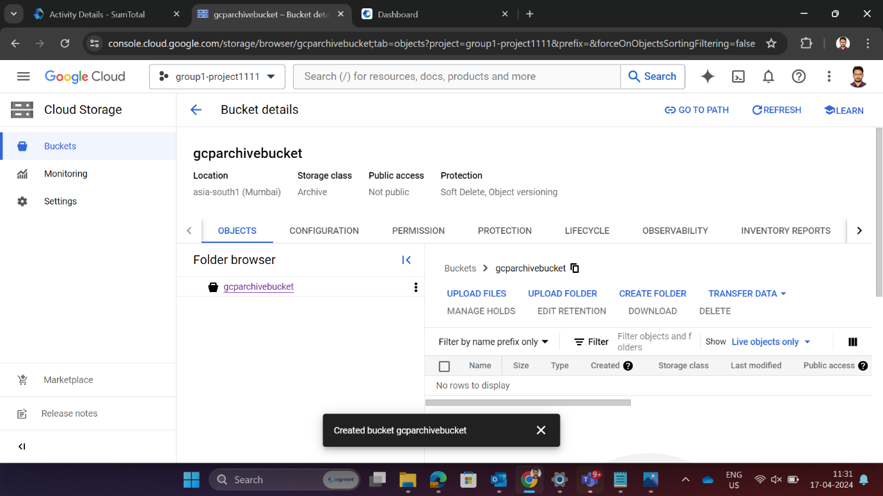

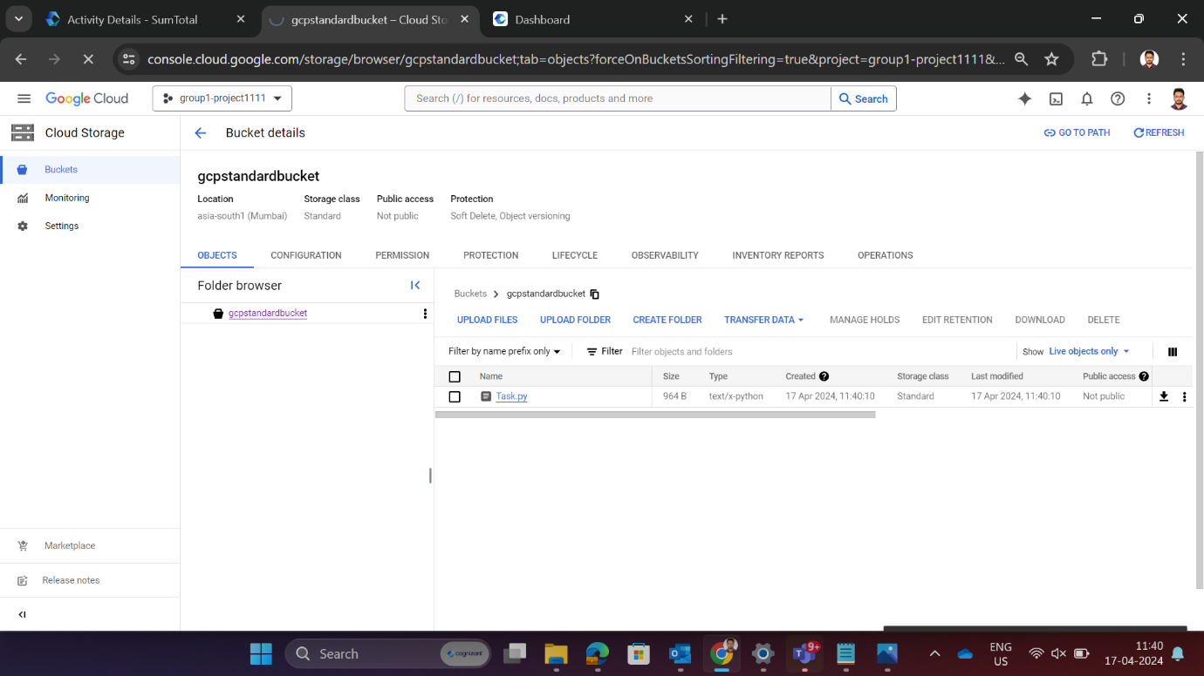Upload a file into standard bucket

Create a lifecycle policy for standard bucket

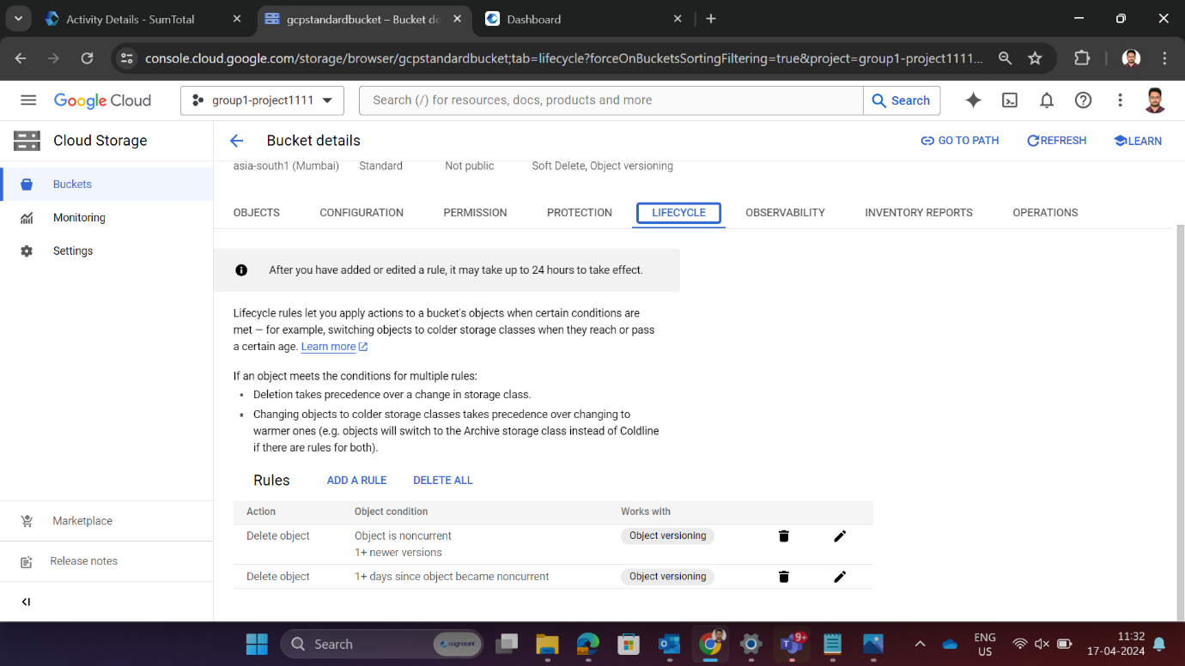

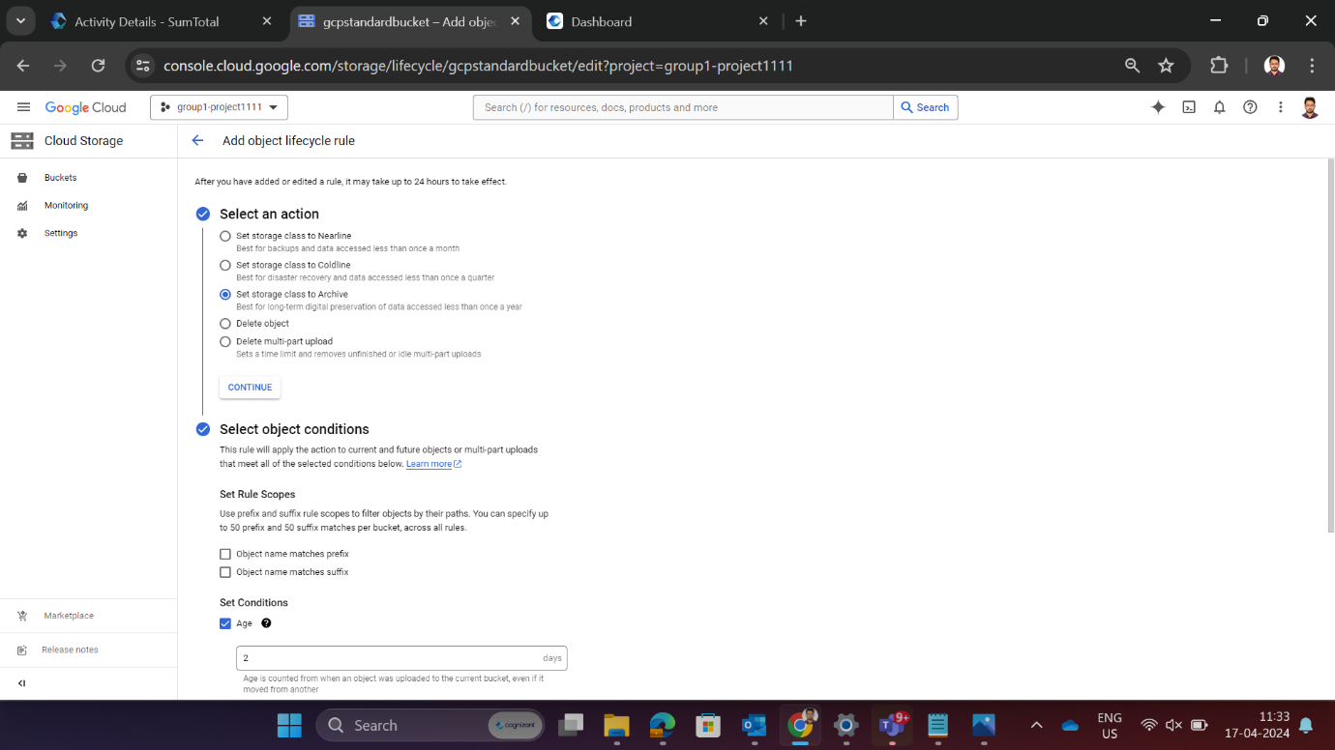Add a rule

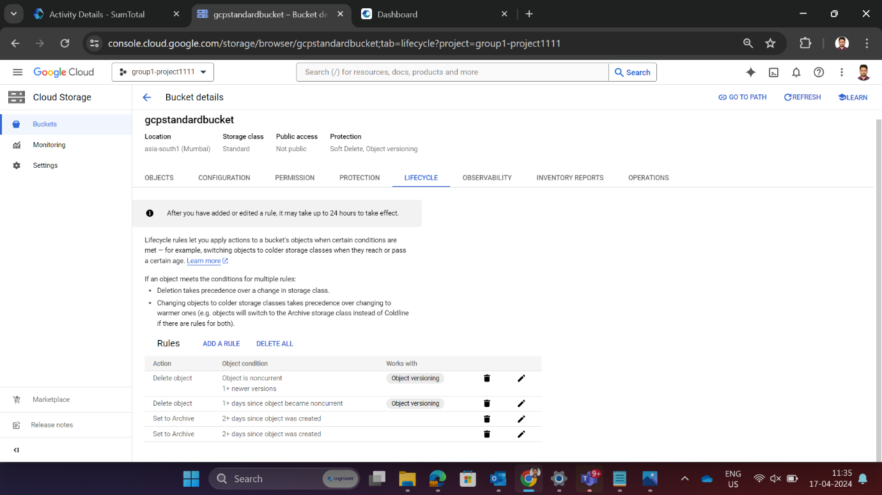

Transfer a job from standard bucket to archive bucket

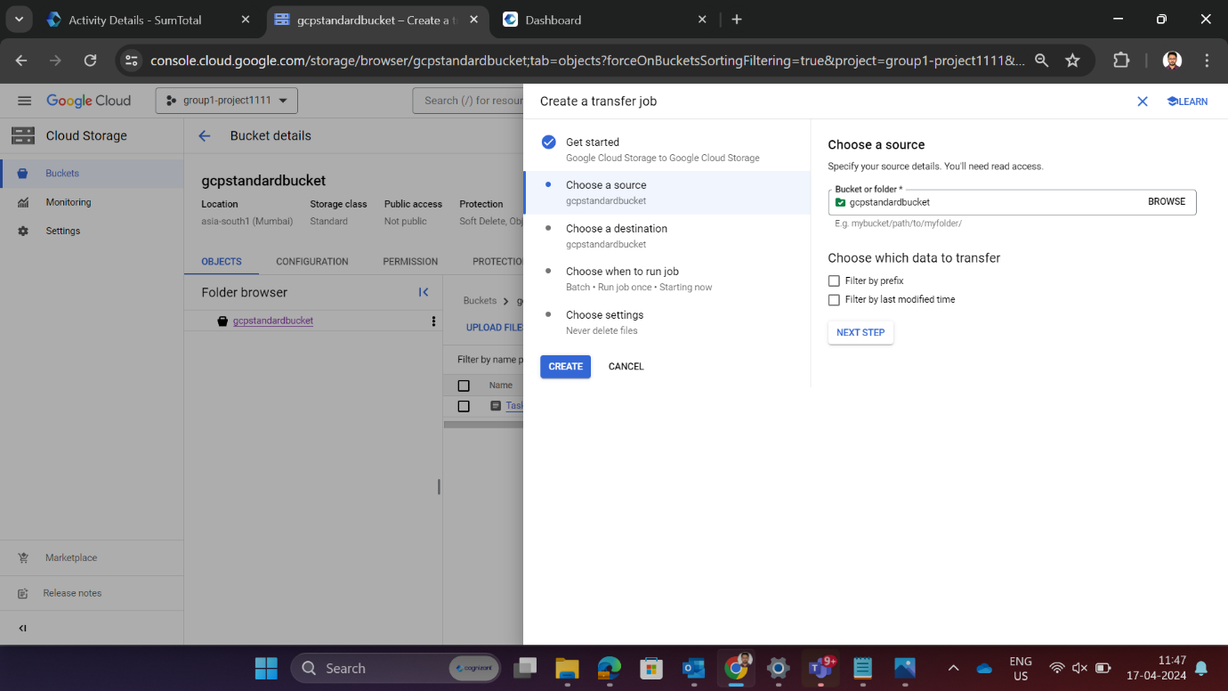Choose a source

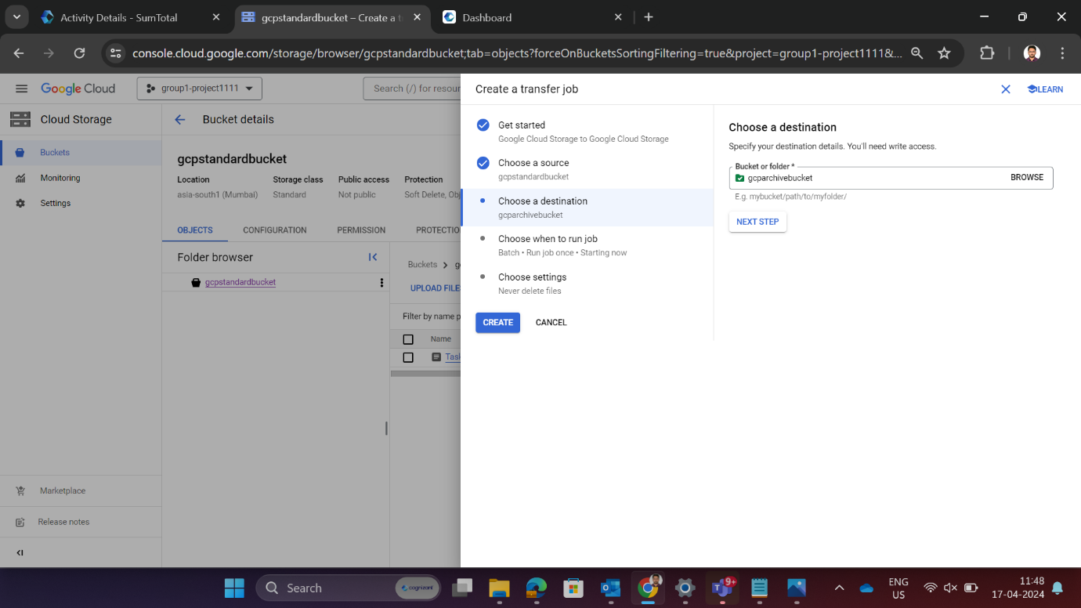Choose a destination

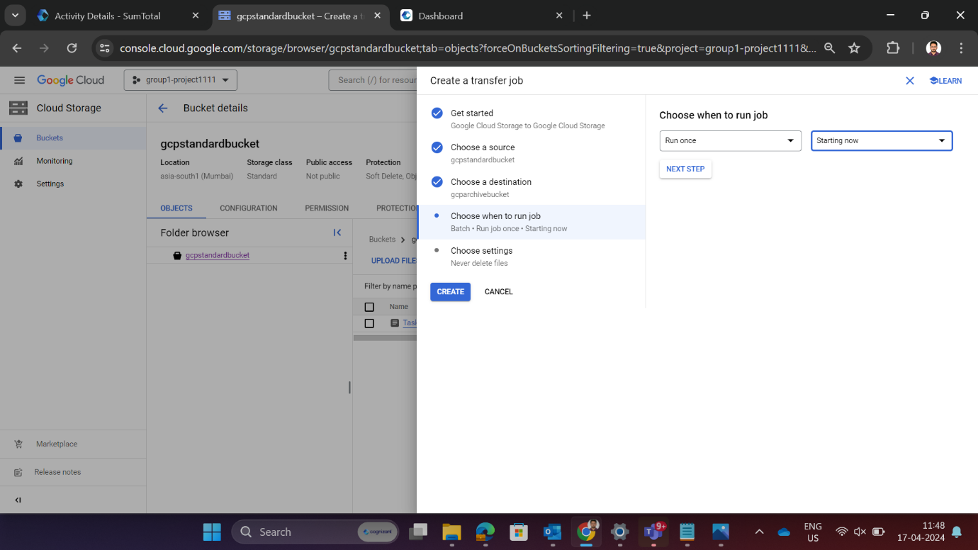Choose when to run job

Successful creation of job transfer

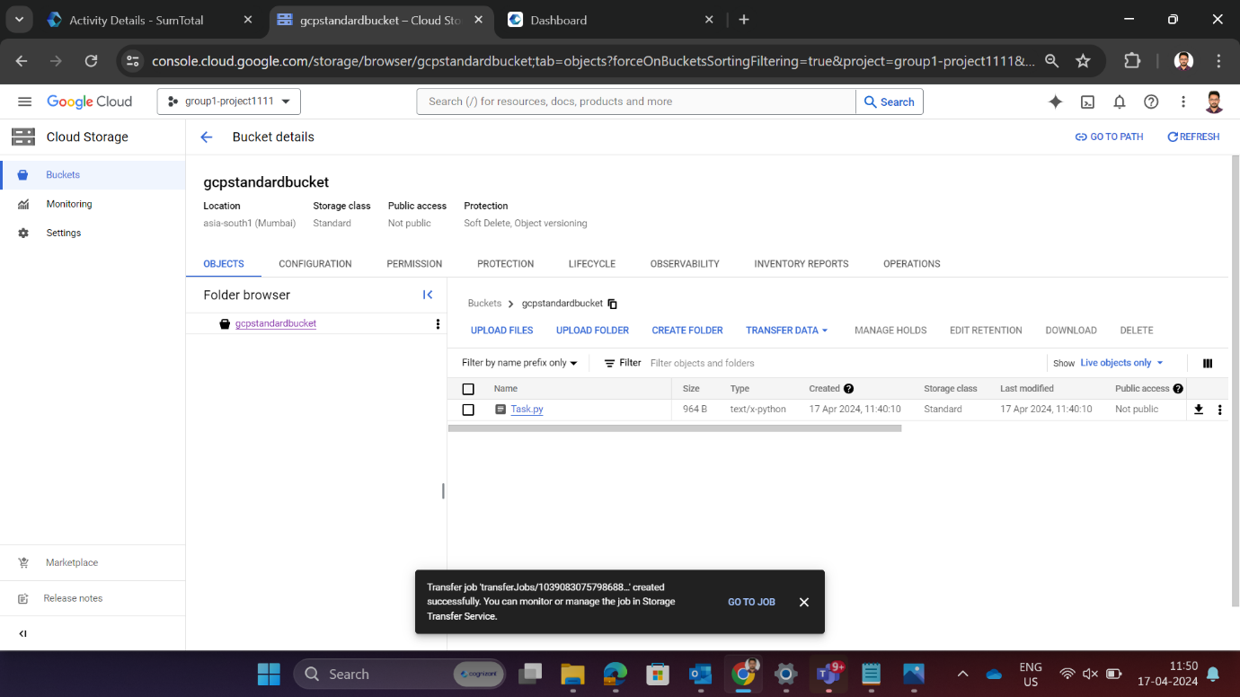

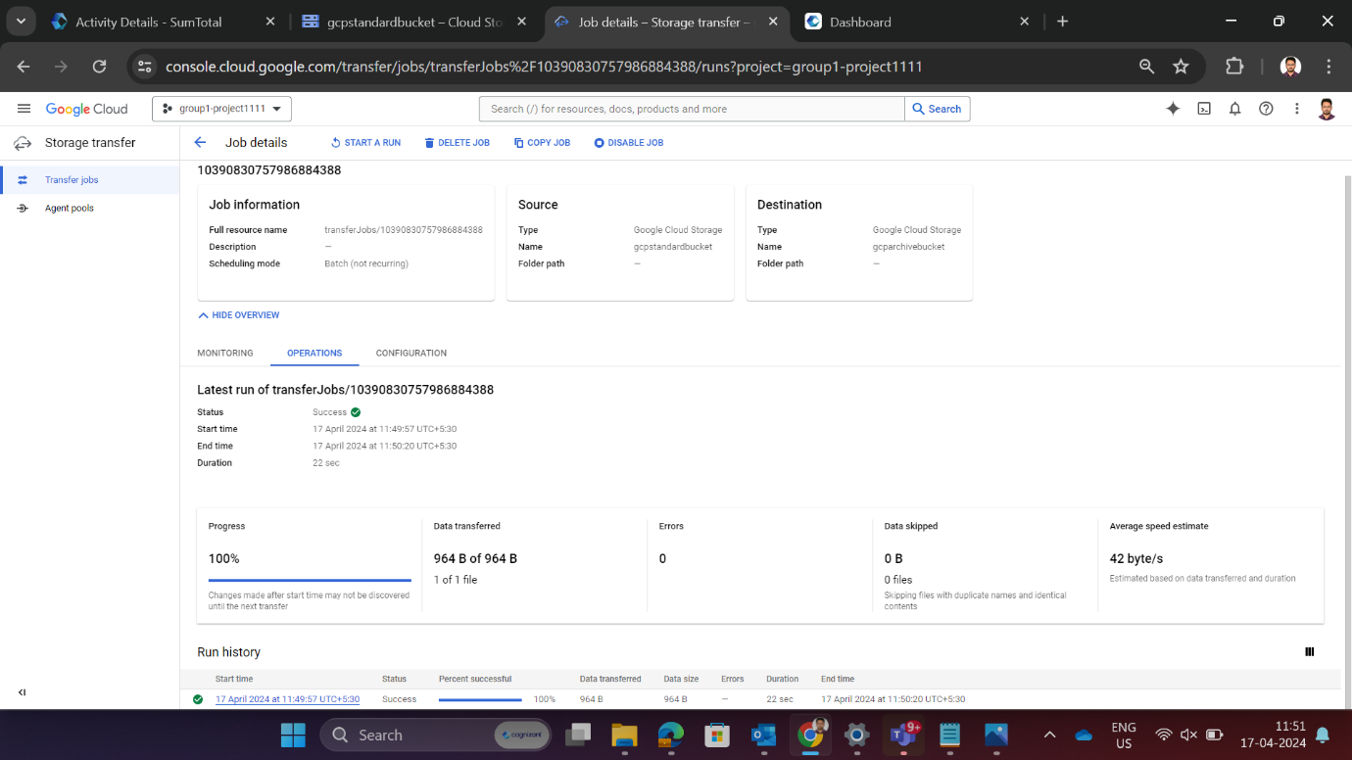Displays a job details

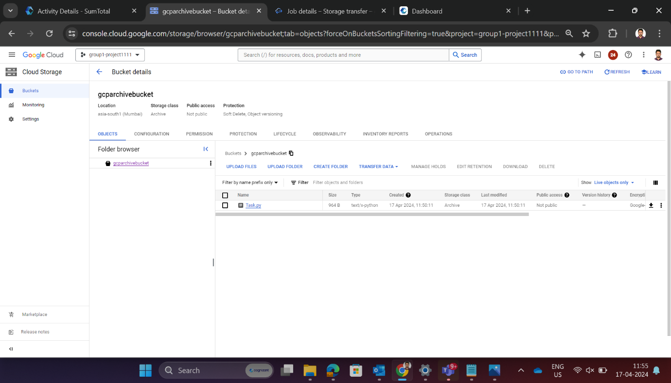Job has been transferred successfully from standard to archive bucket

Running of job once again

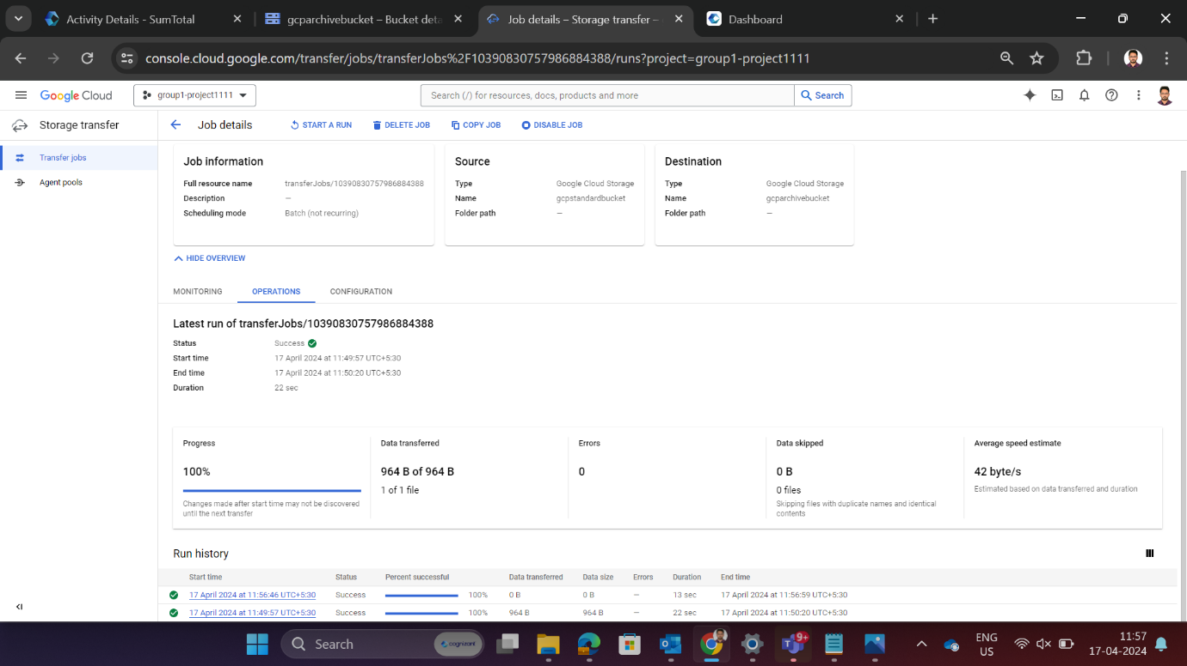

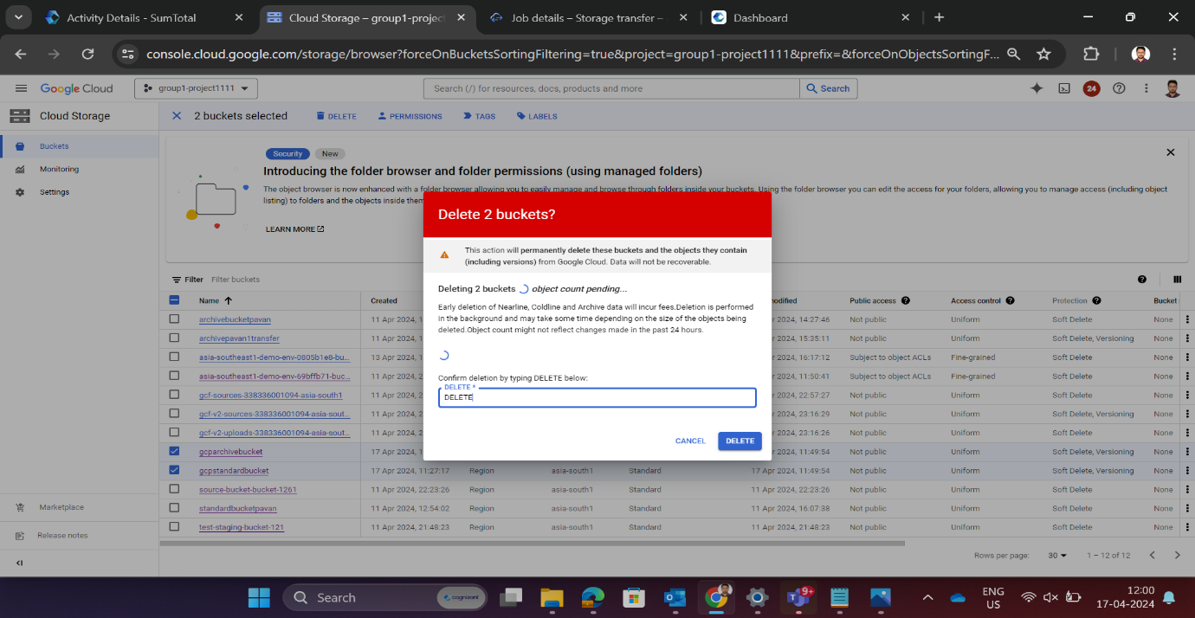Deletion of buckets

Via Cloud shell

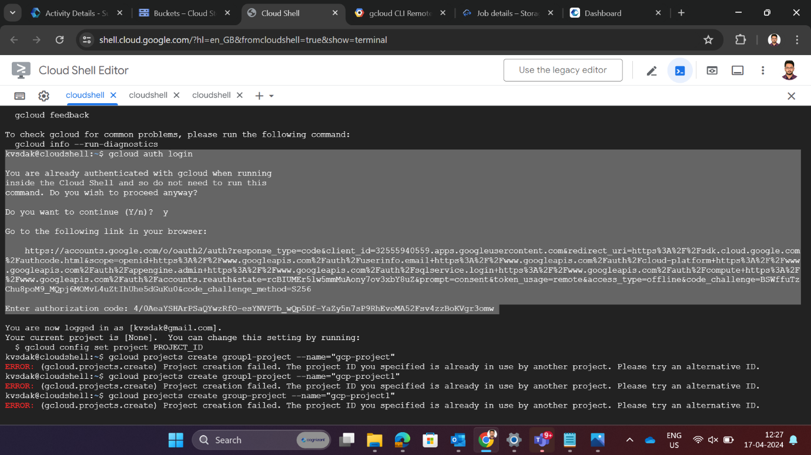To authenticate identity with GCP via command line

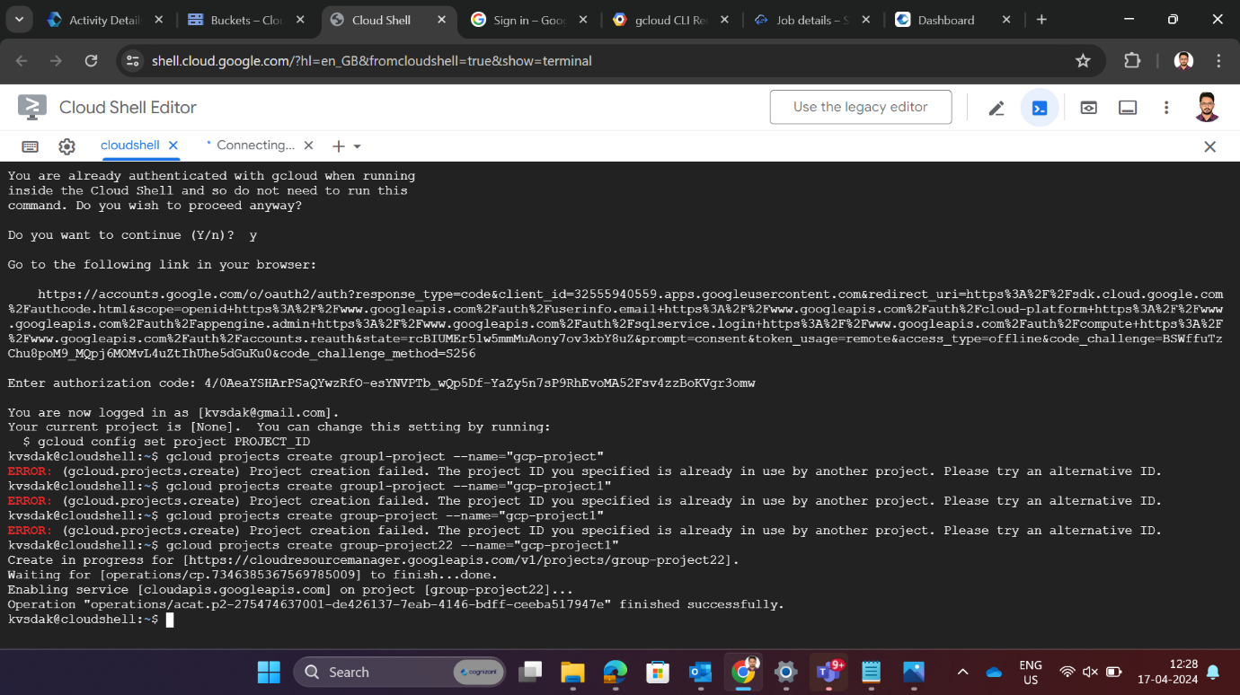Create a project

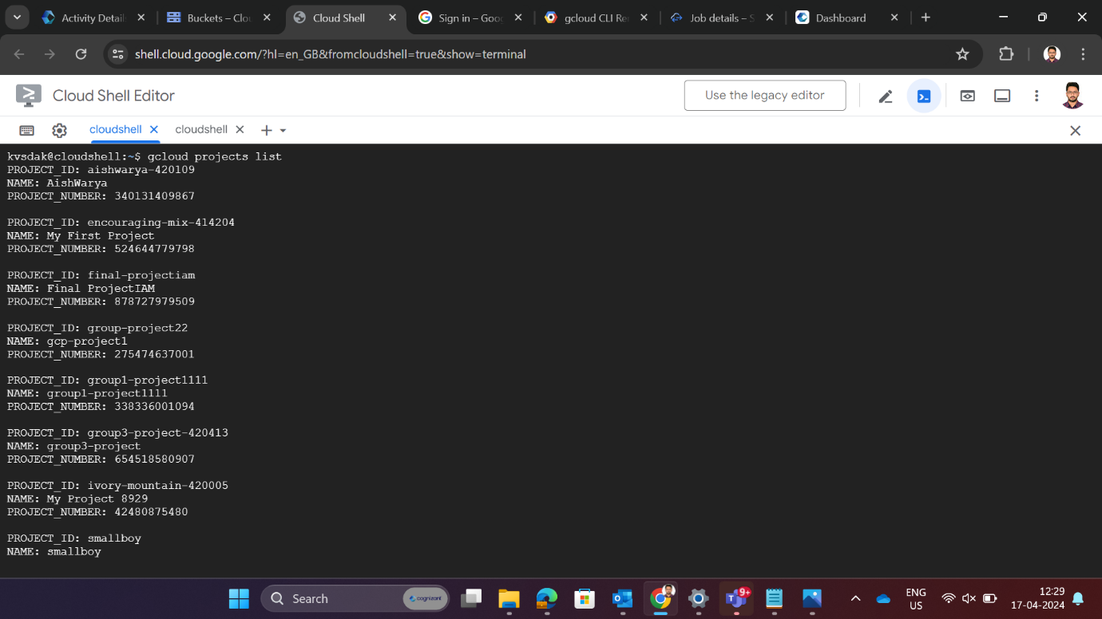List the projects

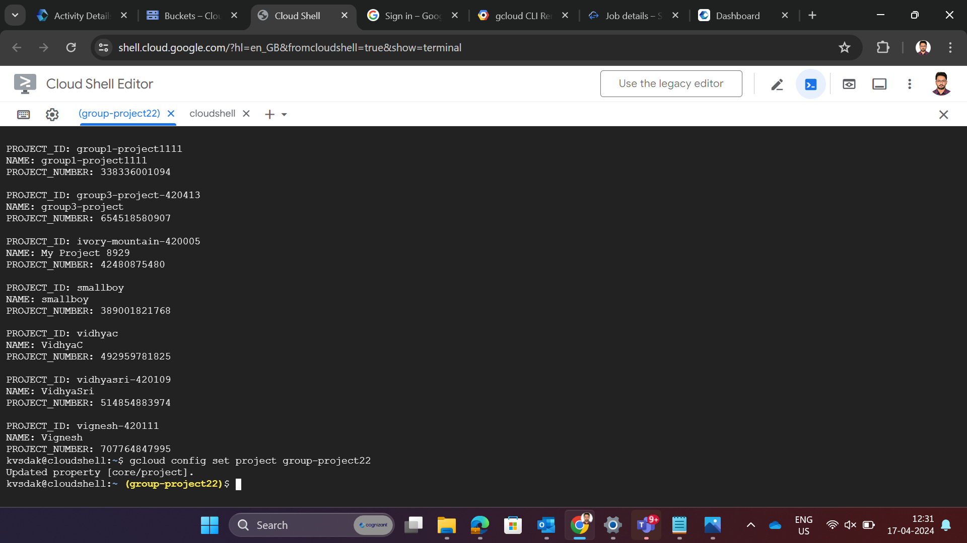To set the default GCP project for the current environment

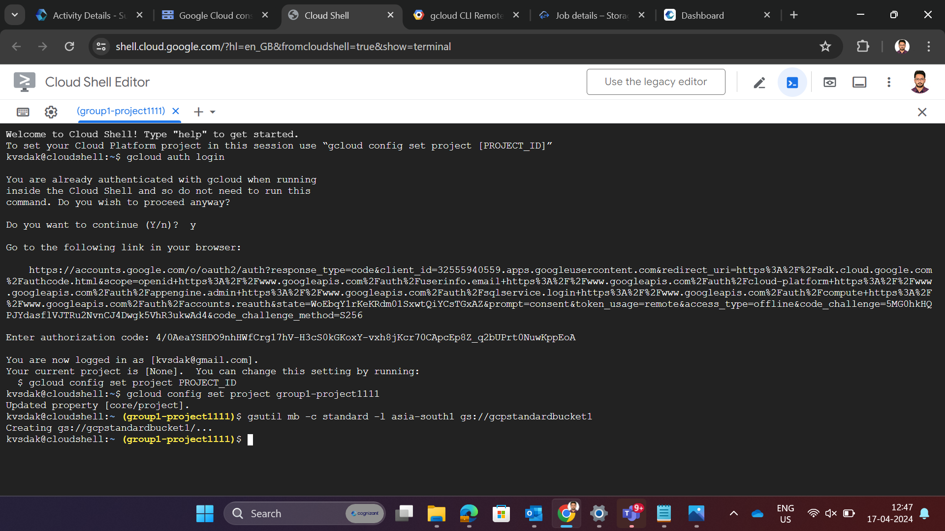Create a standard bucket

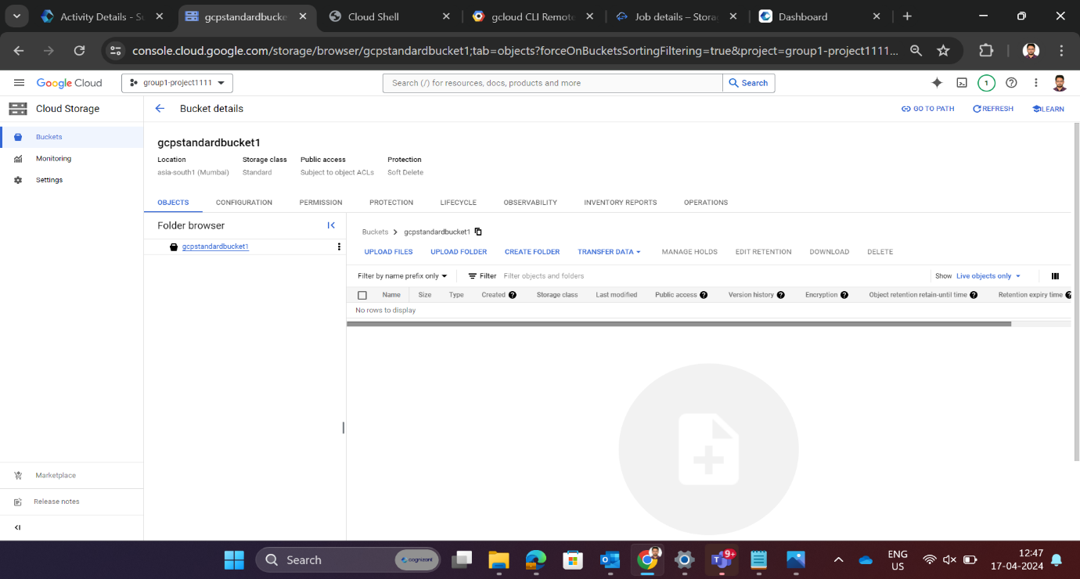Check whether the bucket is created

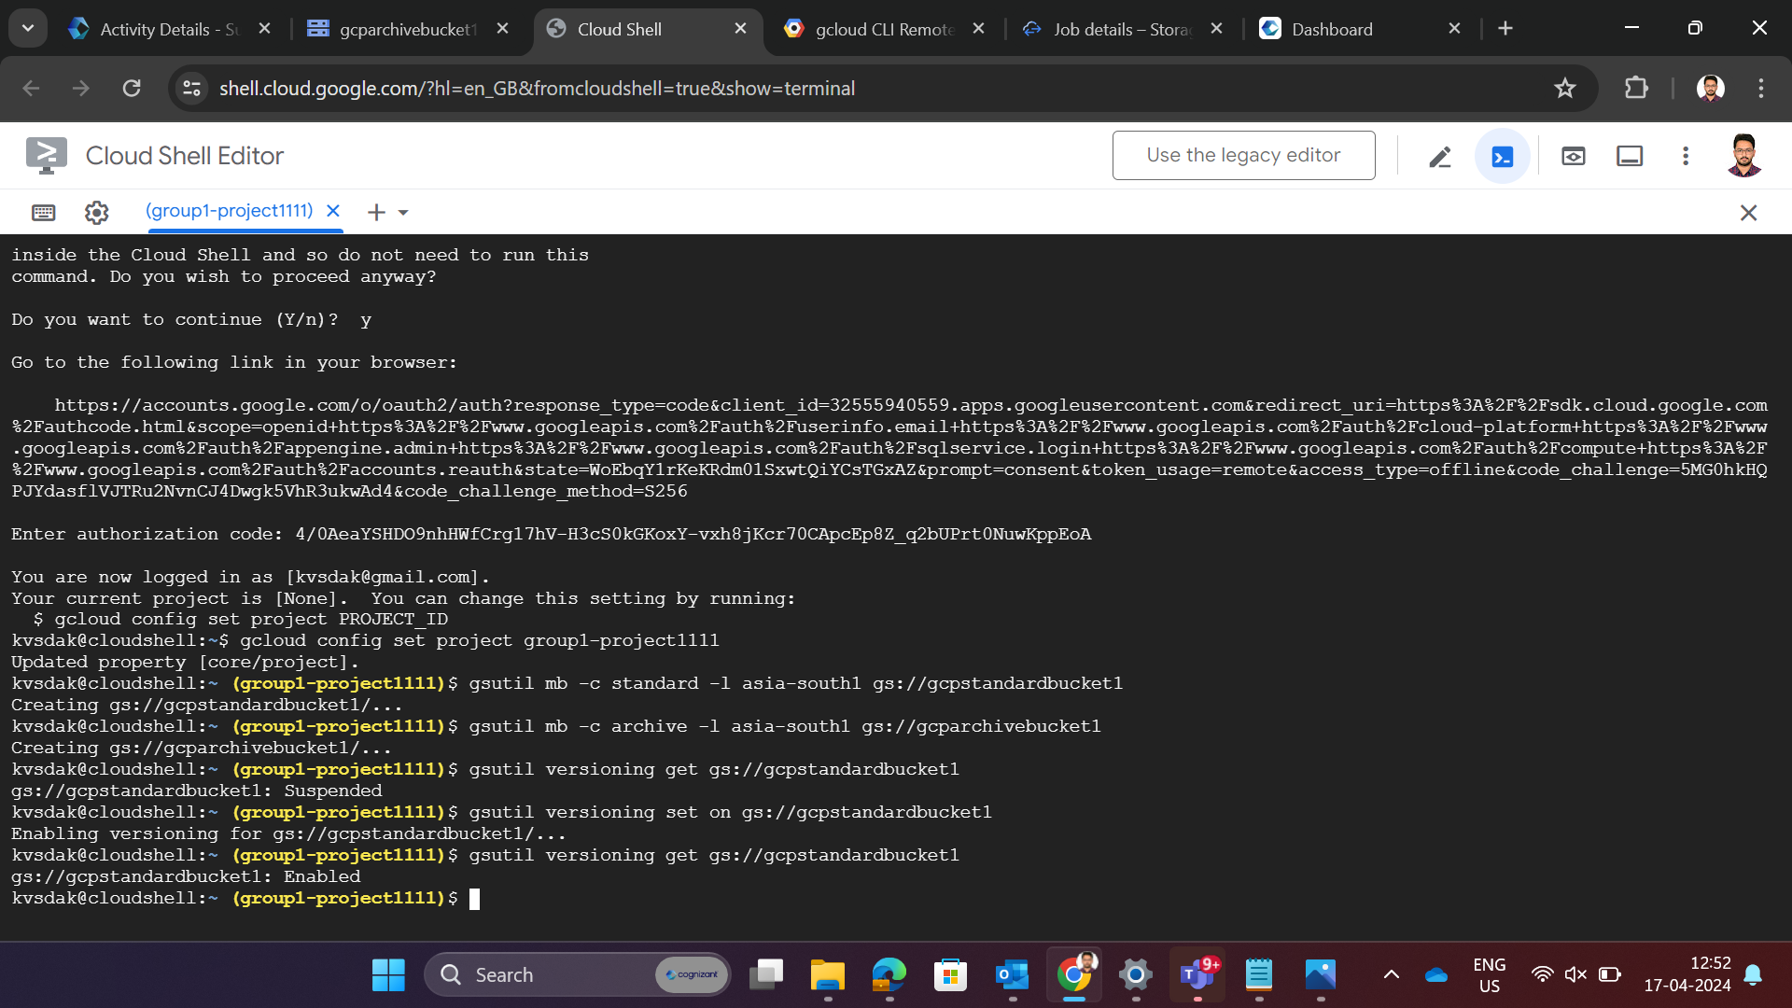Create a archive bucket

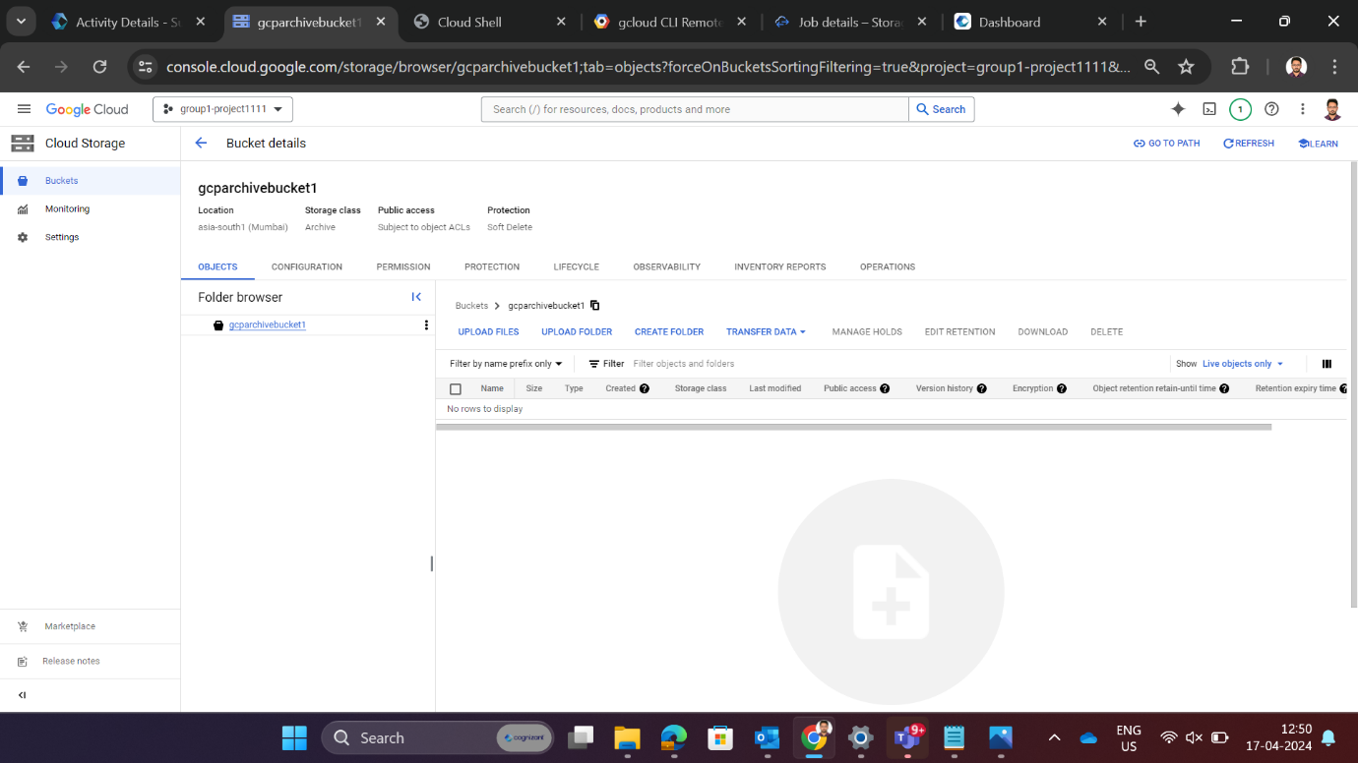Check whether the bucket is created or not

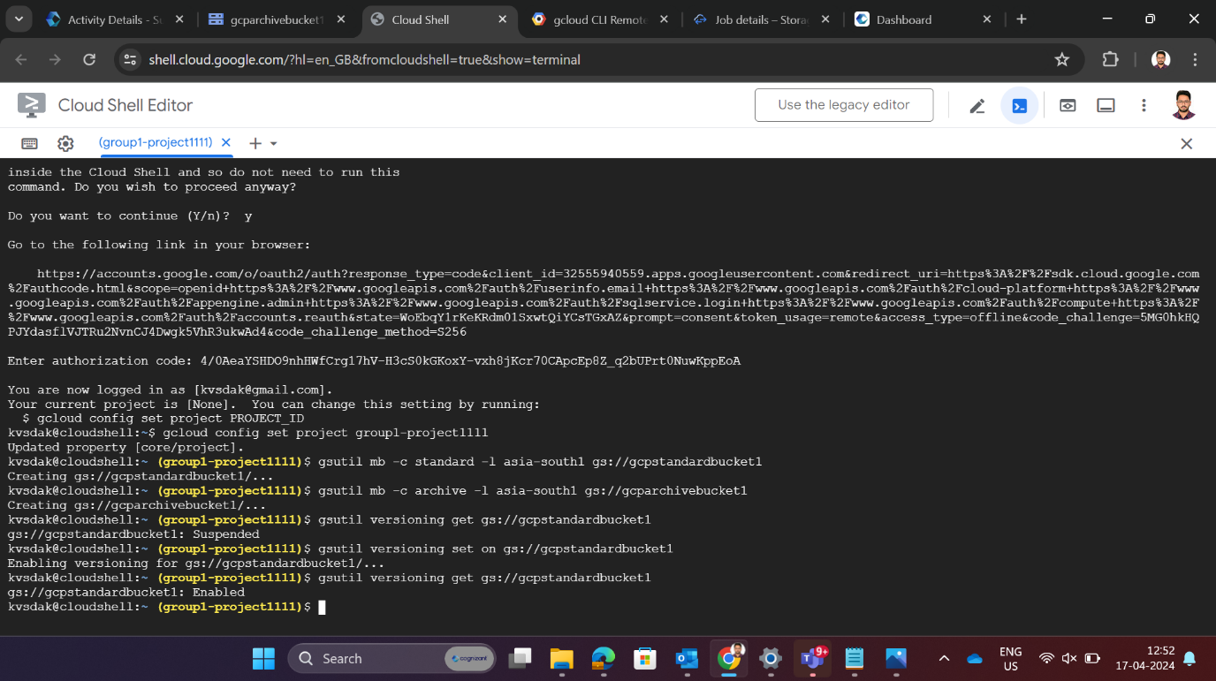Enable versioning

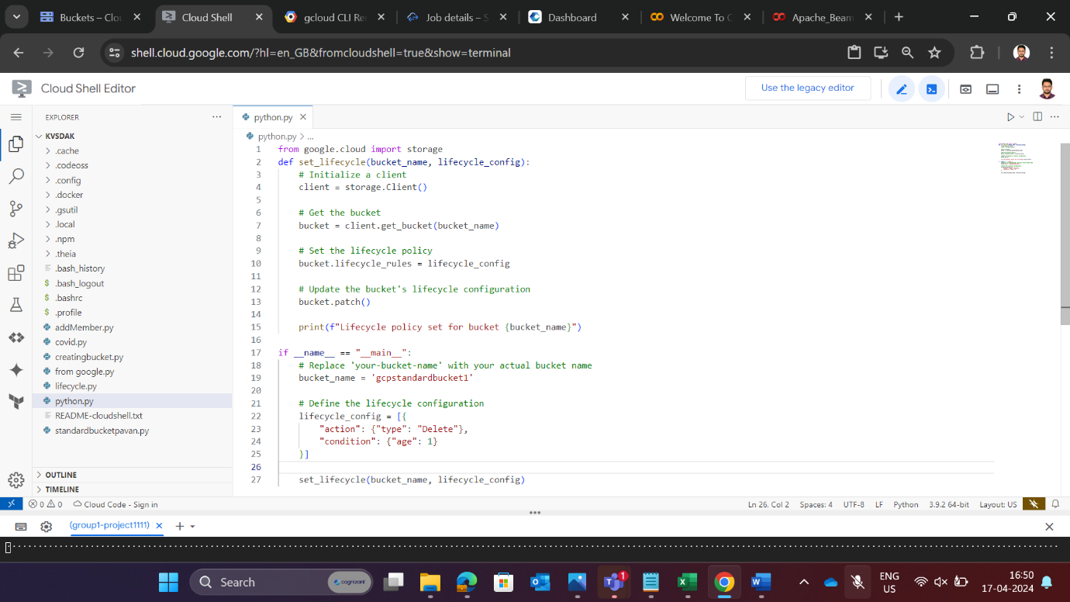Set a lifecycle policy for standard bucket

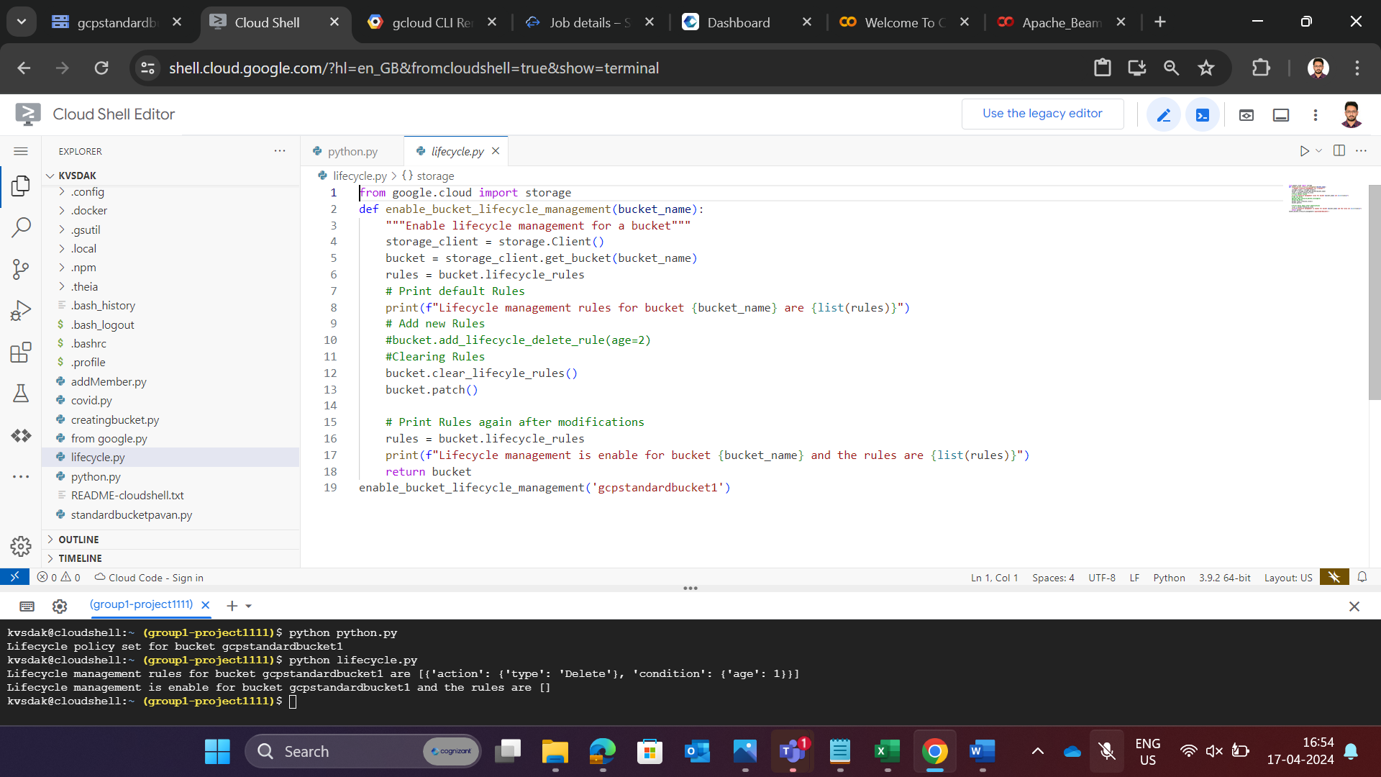

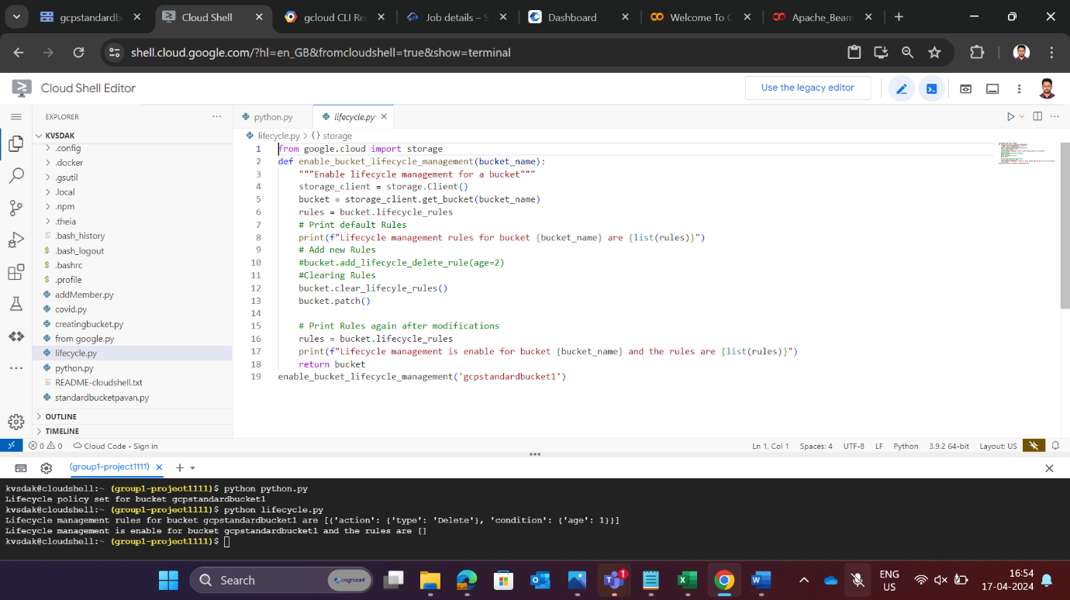Enable a lifecycle policy

Check whether a lifecycle policy has been enabled

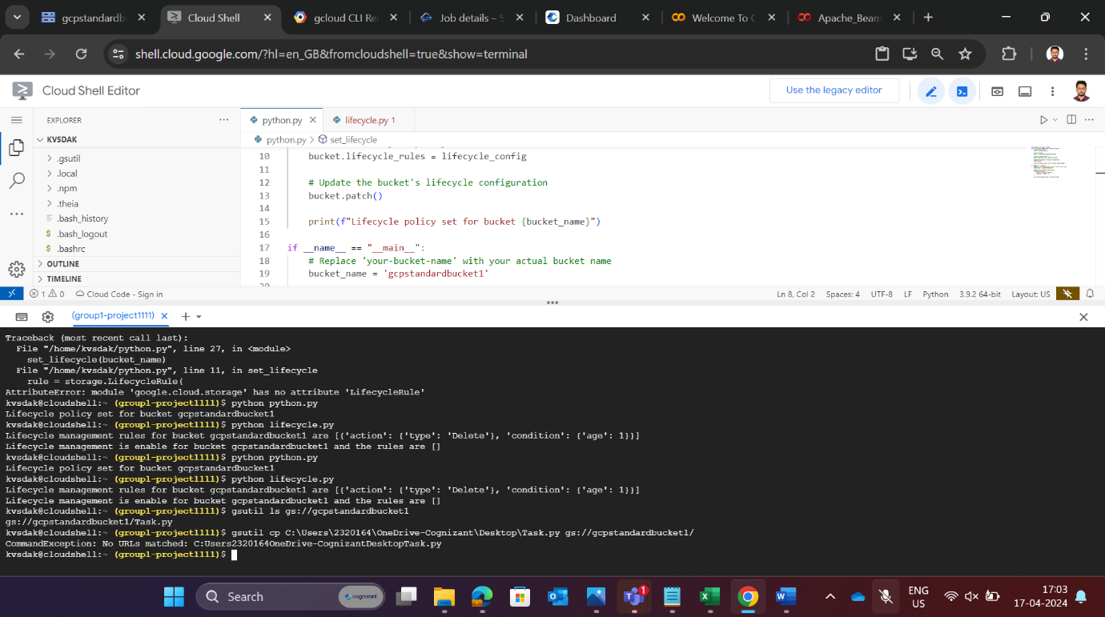List the files inside a standard bucket

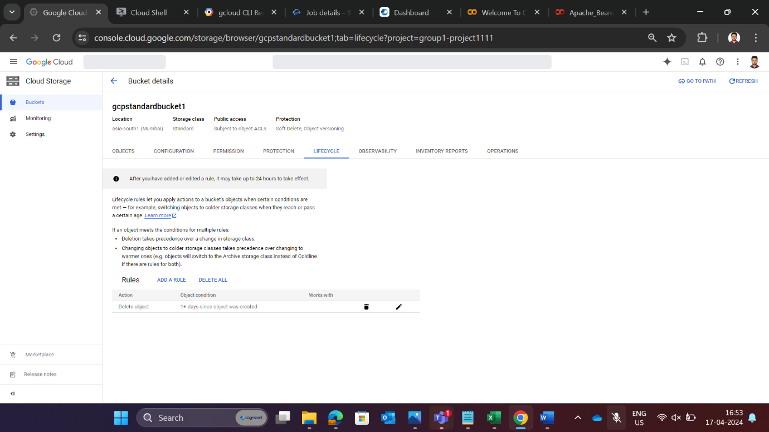

Via Python

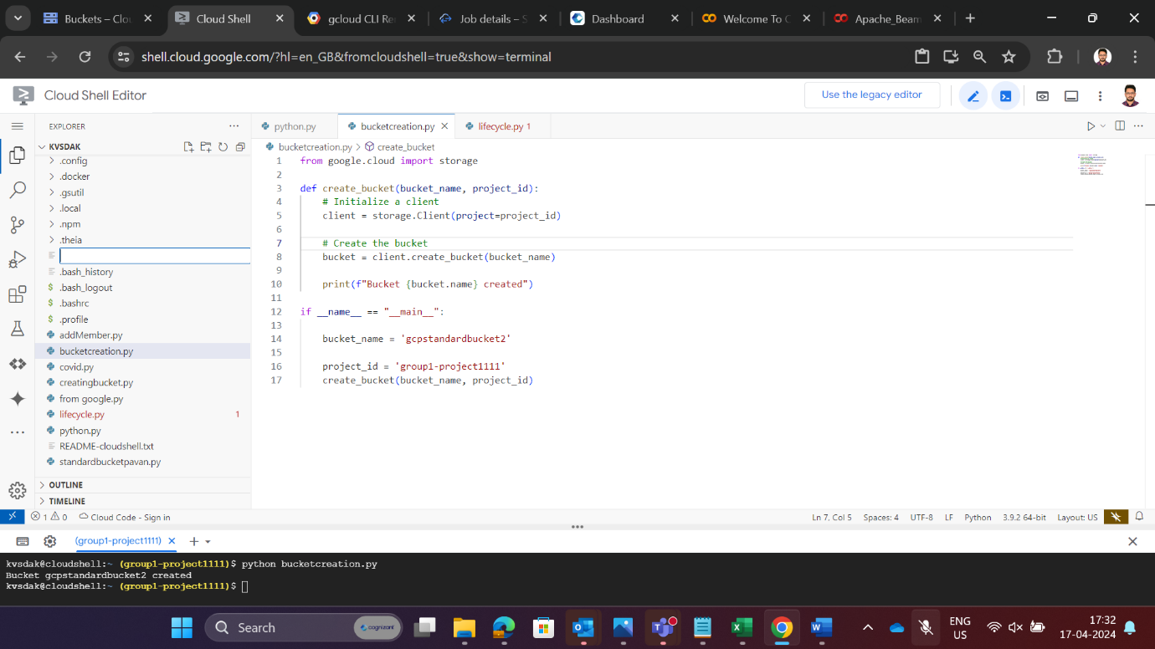Create a bucket

List the bucket

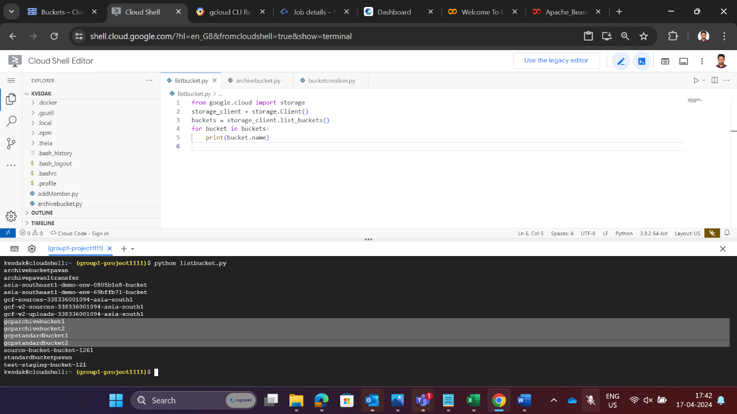

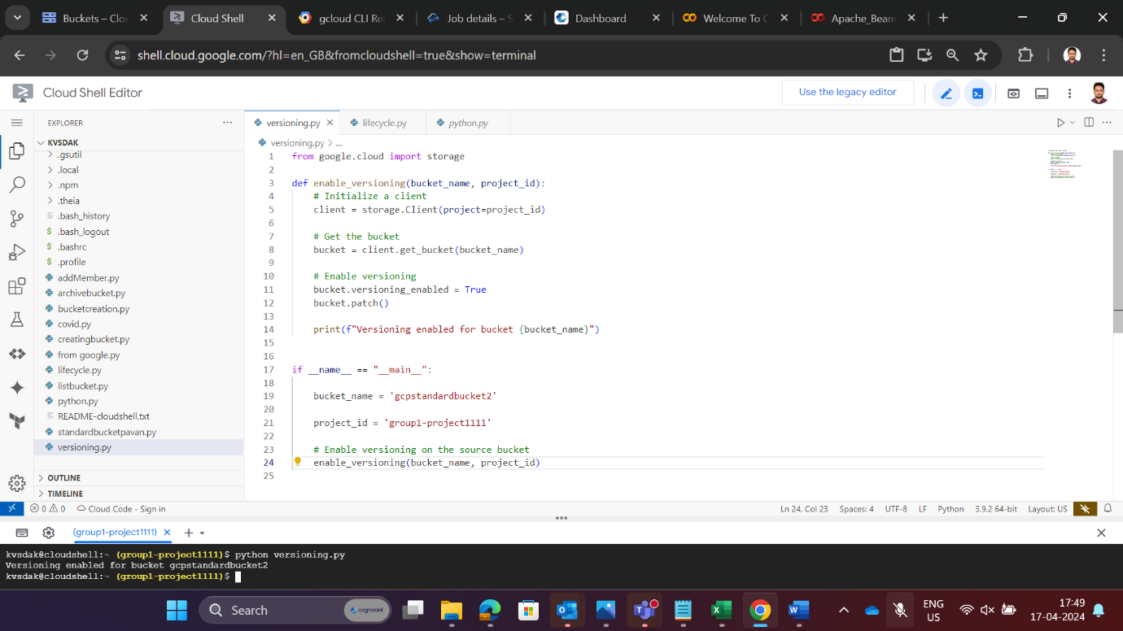Enable versioning

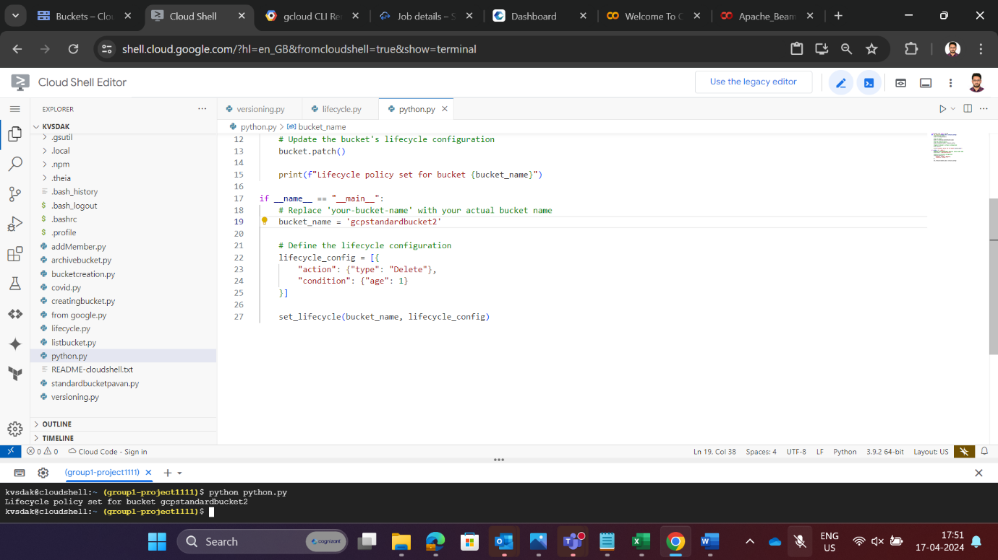Set a lifecycle policy

Enable a lifecycle policy

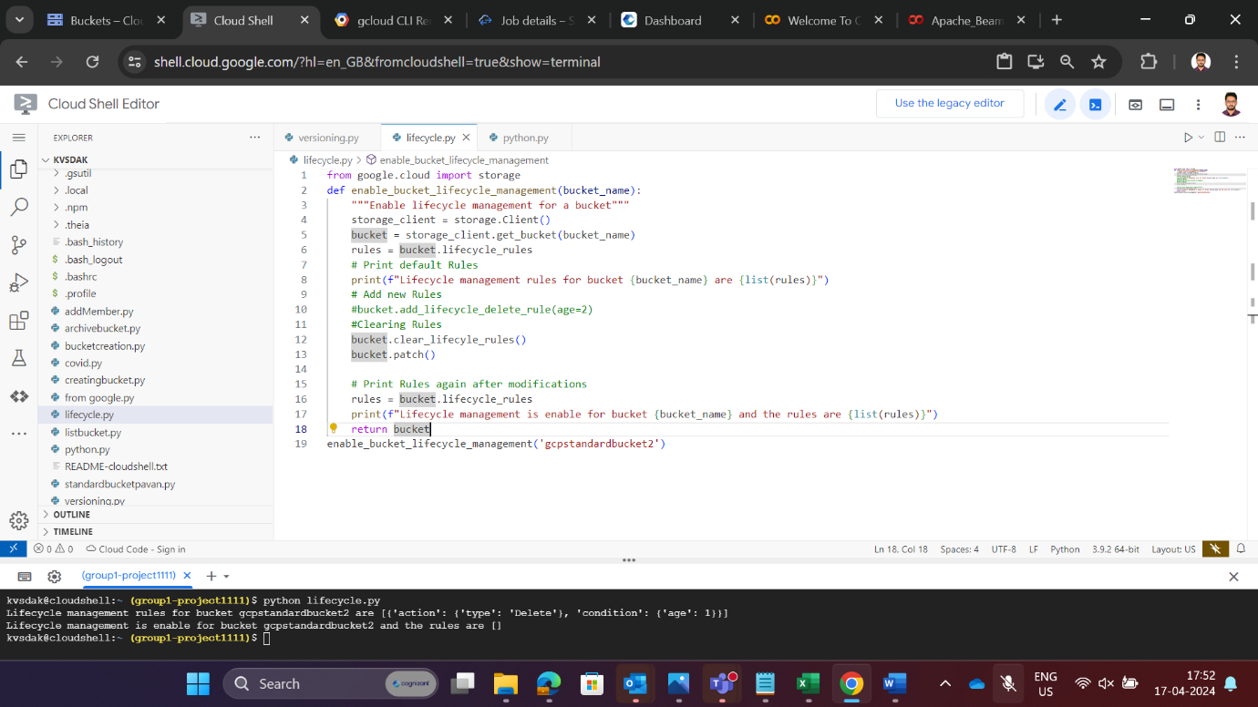

**CONCLUSION**

The successful implementation of Standard and Archive buckets with versioning and lifecycle policies on Google Cloud Platform (GCP) represents a significant milestone in optimizing data storage management. By leveraging these storage solutions and features, organizations can achieve greater efficiency, durability, and flexibility in managing their data assets. Through the deployment of Standard buckets, organizations can store frequently accessed data with high performance and availability, ensuring timely access to critical information. Meanwhile, Archive buckets provide a cost-effective solution for long-term storage of infrequently accessed data, enabling organizations to minimize storage costs without sacrificing data durability.

The integration of versioning enhances data resilience by maintaining multiple versions of objects, safeguarding against accidental deletions or modifications and facilitating data recovery processes. Additionally, lifecycle policies automate the management of data lifecycle, enabling seamless transitions of objects between storage classes based on predefined criteria, thereby streamlining data management workflows and reducing operational overhead. By achieving these objectives, organizations can optimize their data storage strategies, improve data governance practices, and enhance operational efficiency on Google Cloud Platform. Moving forward, continued evaluation and refinement of storage configurations and policies will be essential to adapt to evolving business requirements and maximize the benefits of GCP's storage offerings. In essence, the implementation of Standard and Archive buckets with versioning and lifecycle policies empowers organizations to unlock the full potential of their data assets, enabling them to focus on innovation and growth in the digital age